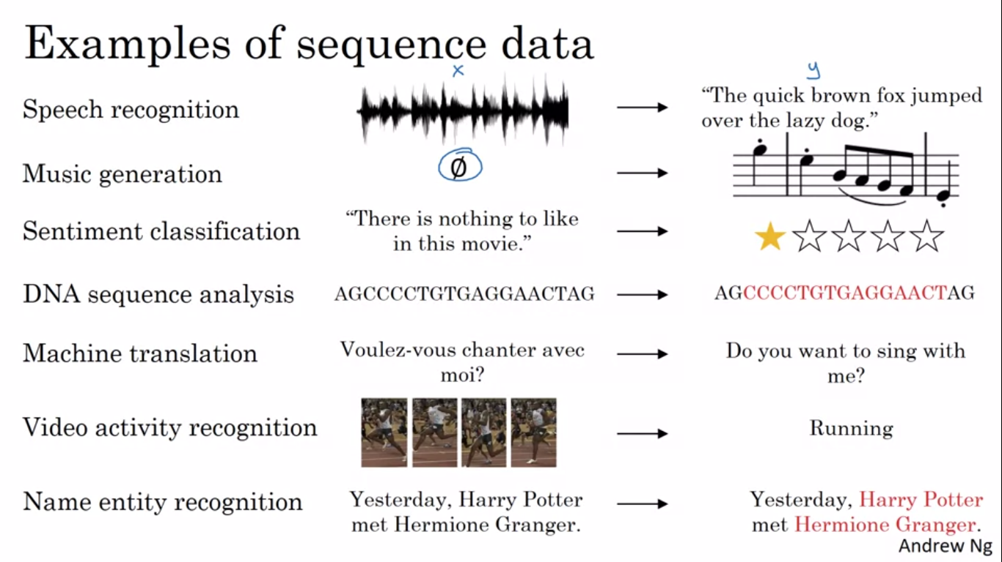

**NOTATION:** we use <> for denoting nth feature in I/O and () for nth training example

Tx,Ty to denote total number of features in I/O

We use a dictionary/vocabulary of words and then do one hot encoding for the wordwe gound in the input sequence and create Tx such vectors

WHY WE DON'T USE STANDARD NETWORK:

1)I/O can be of different length for different examples and is not fixed

2)number of parameters will be too large,it should not learn word with positions

**RECURRENT NEURAL NETWORKS:**

The current input is passed along with precious output(activation) and same weights are used for each feature and activation and output(Wax,Waa,Wya)

*Only uses info from earlier features*

The activation function usually used to find activation is tanh

For each y<i> loss function is calculated as L<i>=-ylog(ybar) - (1-y)log(1-ybar)

Total L=sum of L over all Ty and then backprop is done going back in time

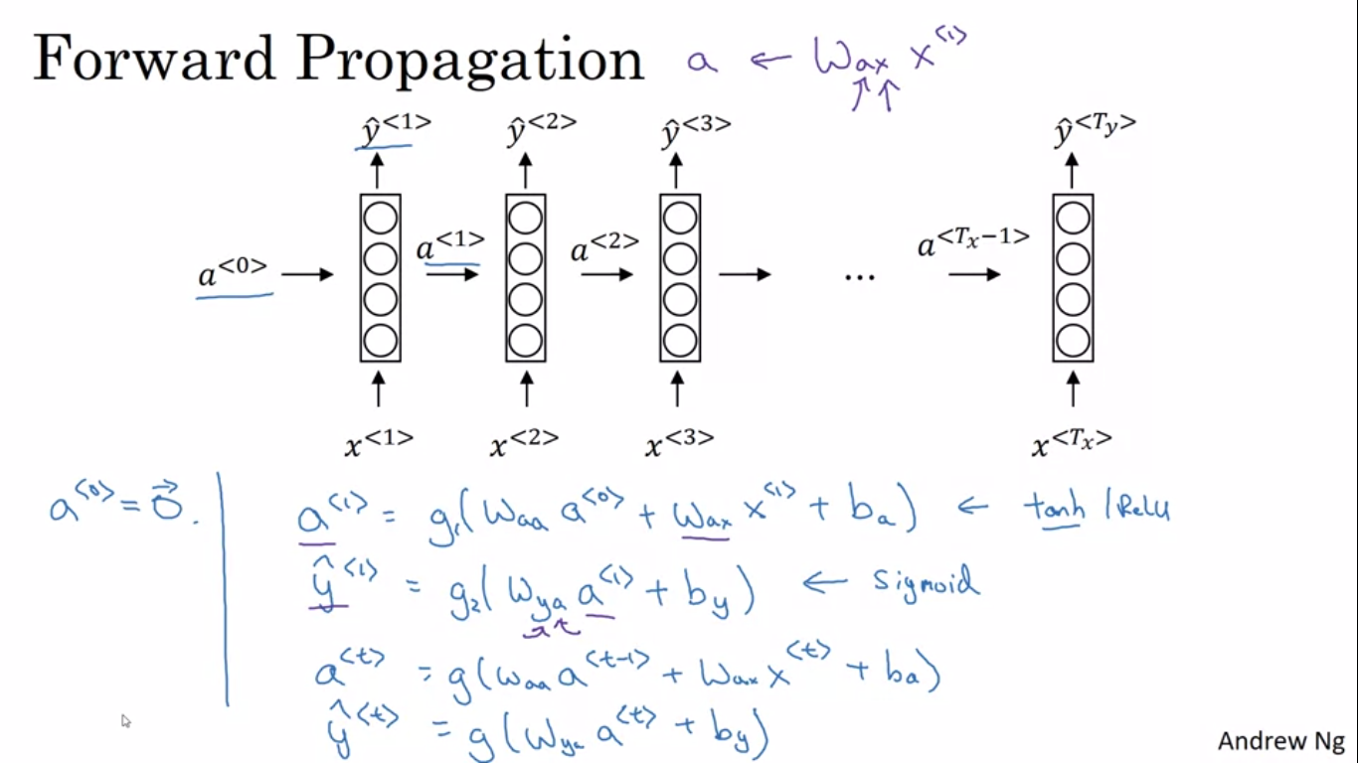

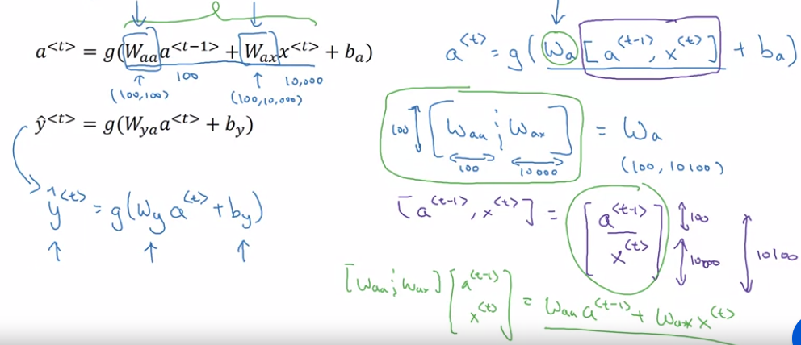

One to many: musicc/sequence generation

Many to one: sentimental analysis

Many to many 1: name identity model

Many to many 2: language translation

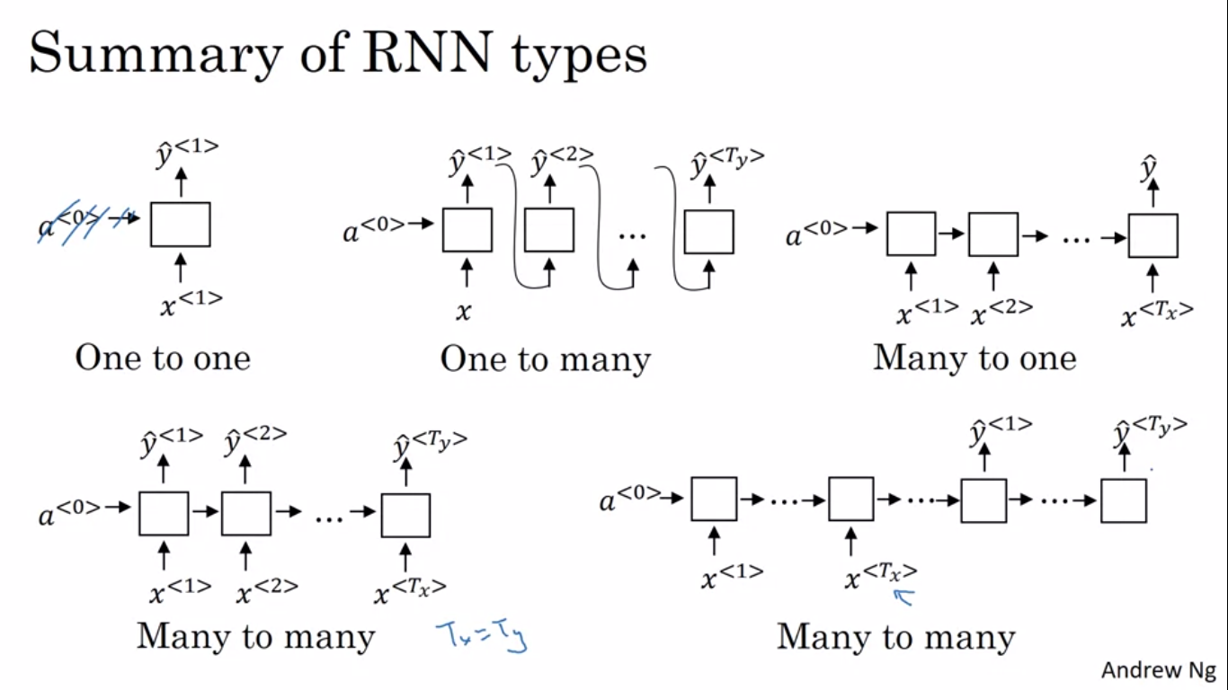

**LANGUAGE MODELS:**speech recognition,machine translation

given any sentence,gives the probability of that sentence

<EOS> token is use to denote end of sentence

Corpus: NLP terminology to represent very large body/set

Predicts softmax probability of one word at a time, given earlier words in a sequence

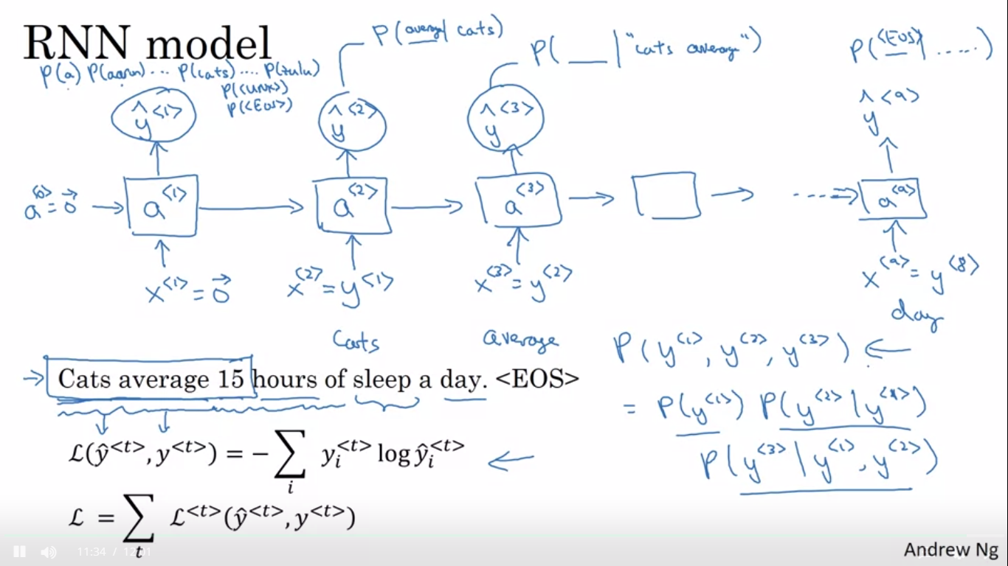

**Sampling language models:**

Instead of y as input for next x,yhat generated in last time stamp is used as input for next word. End the sentence at encountering EOS

Instead of word model, Character model can also be used

Advantage: all the words can be taken care of

Disadvantage: sequence gets very large, difficult to train, large compute required

character language models are not as good as word level language models at capturing long range dependencies between how the the earlier parts of the sentence also affect the later part of the sentence

Used for specific application

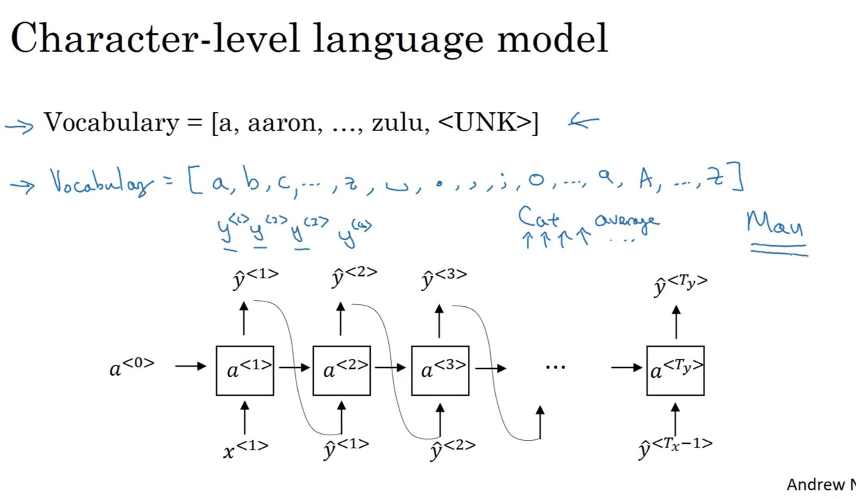

**VANISHING GRADIENTS IN RNN:**

the basic RNN model has many local influences, meaning that the output y hat<n> is mainly influenced by values close to y hat<n> and any value is mainly influenced by inputs that are somewhat close. It's difficult for the output here to be strongly influenced by an input that was very early in the sequence. This is because whatever the output is, whether this got it right, this got it wrong, it's just very difficult for the error to backpropagate all the way to the beginning of the sequence, and therefore to modify how the neural network is doing computations earlier in the sequence.

**EXPLODING GRADIENTS:**

the exponentially large gradients can cause your parameters to become so large that your neural network parameters get really messed up. It turns out that exploding gradients are easier to spot because the parameter has just blow up. You might often see NaNs, not a numbers, meaning results of a numerical overflow in your neural network computation. If you do see exploding gradients, one solution to that is apply gradients clipping. All that means is, look at your gradient vectors, and if it is bigger than some threshold, re-scale some of your gradient vectors so that it's not too big, so that is clipped according to some maximum value

**GATED RECURRENT UNIT(GRU):** used for long range dependencies

We use a vector of bits c(memory cell),for keeping track of decision for later words dependent on earlier words

We use a concept of gate for deciding whether to update c or not

Here gama would be zero most of the times so the value of c is maintain and it helps overcome vanishing gradients

C,c tidle ,gamma have the same dimensions

Gamma r: for relevance

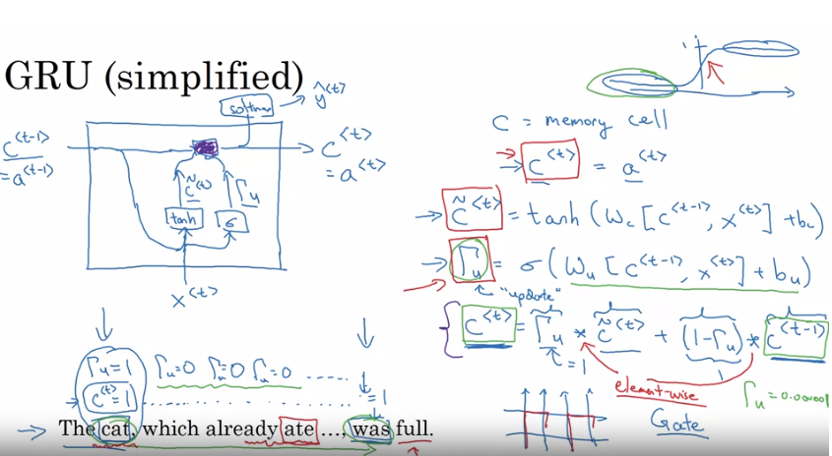

Gamma r is added for relevance by experimenting many alternatives

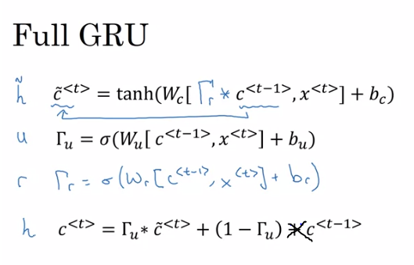

**LONG SHORT TERM MEMORY(LSTM):**

Here instead of gamma and 1- gamma,gamma update and forget are calculated separately for adding update to c<t-1> ,another gamma output is used to to find a<t> from c<t>

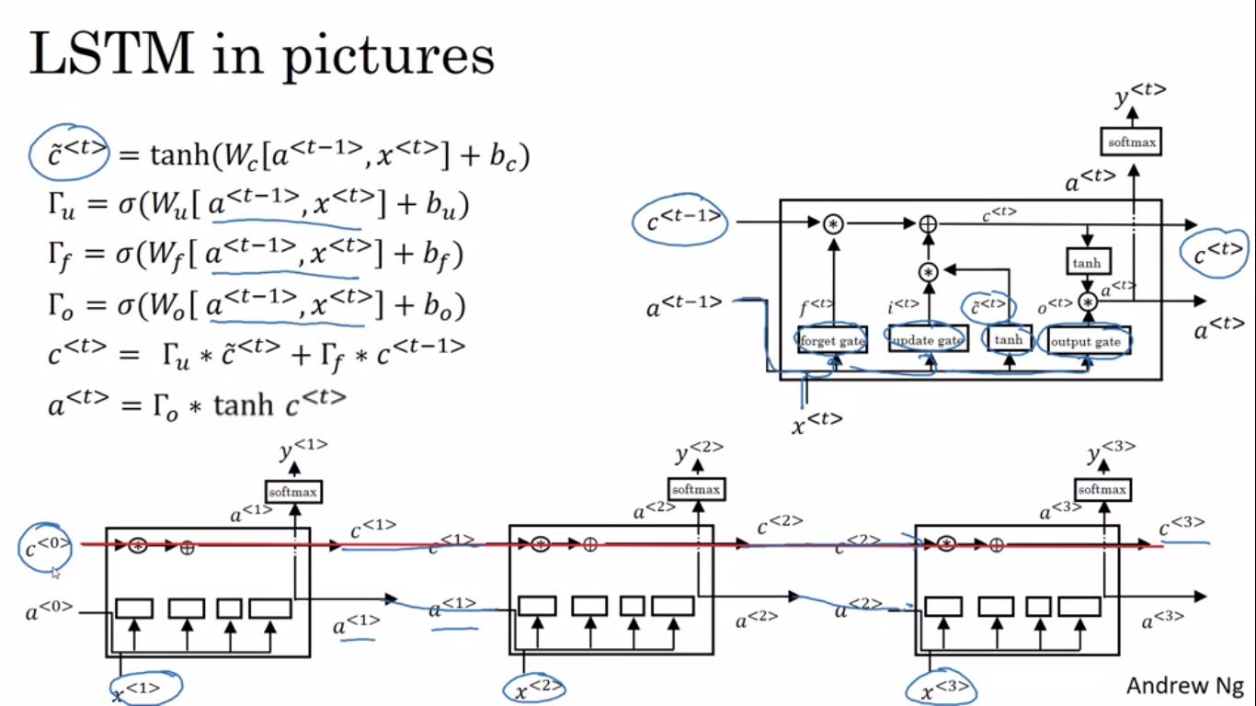

Here c<0> can be passed directly along the straight line to c<3>

Variant:peephole connection, gamma values depend on a<t-1>,x<t>,c<t-1>

*GRU IS COMPUTATIONALLY FASTER BUT LSTM IS MORE FLEXIBLE AND POWERFUL*

**BIDIRECTIONAL RNN(BRNN):**

Only info given previously isn't enough for making predictions, so we use info from upcoming data also.In BRNN in forward prop activations come from behind and ahead and are used to do predictions y

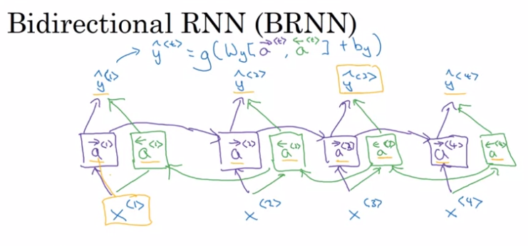

Disadvantages: whole data is required before starting to make predictions so used in NLP but more complex models are used in speech recognition

NLP APPLICATIONS: BRNN WITH LSTM BLOCKS

**DEEP RNN:** multiple layers stacked on top of each other

Rnns dont have very deep nets 3 layers is quite deep because of temporal data, [l] denotes lth layer

Each activation have two inputs, BRNNs can also be deep

After deep RNN each y can be connected to a deep standard neural network

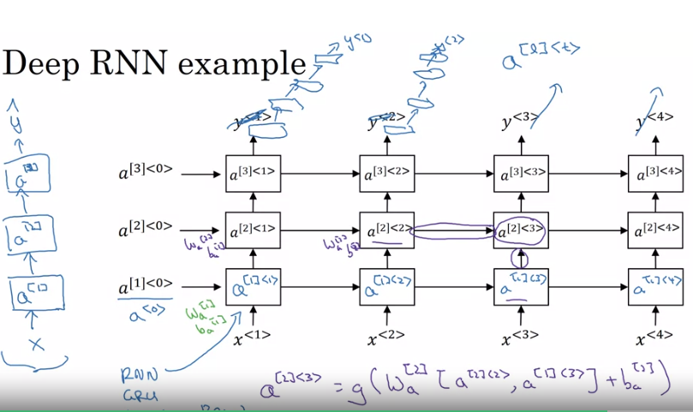

**BACKPROP:**

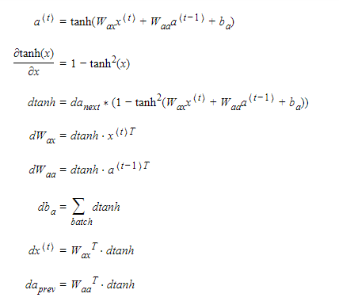

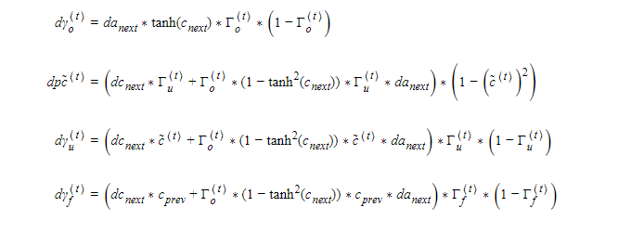

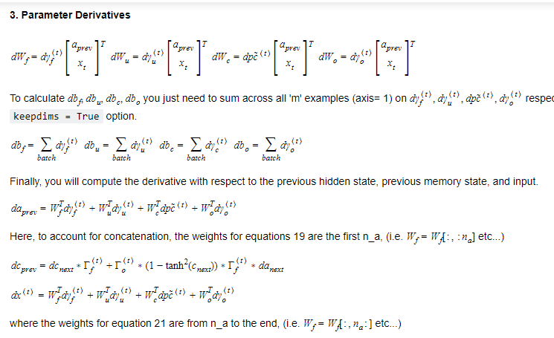

* Very large, or "exploding" gradients updates can be so large that they "overshoot" the optimal values during back prop -- making training difficult
  + Clip gradients before updating the parameters to avoid exploding gradients
* Sampling is a technique you can use to pick the index of the next character according to a probability distribution.
  + To begin character-level sampling:
    - Input a "dummy" vector of zeros as a default input
    - Run one step of forward propagation to get 𝑎⟨1⟩ (your first character) and 𝑦̂ ⟨1⟩ (probability distribution for the following character)
    - When sampling, avoid generating the same result each time given the starting letter (and make your names more interesting!) by using np.random.choice

**WEEK 2:**

O: one hot representation e: feature vector

If we use one hot encoding similarity betw man/woman apple/orange isnt appealing and inner dot product for each set of two words would be 0 so algo doesnt know that apple is more connected to orange then queen

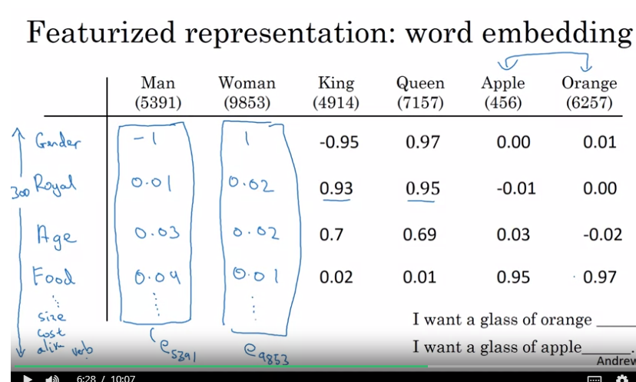

Apple and orange have mostly same features so algo can learn that

**t-SNE:** algo to visualize feature vectors in 2D space, objects with similar features would be plotted close to each other.if there are 300 features, each word would be embedded in a 300D space hence called **word embeddings**

For NLP tasks,word embedding can be used as pre training the model on large(1-100B) word unlabelled data set and then using transfer learning on small labelled dataset so the model can process words not mentioned in small dataset

If you have enough big dataset,we can also do fine tuning

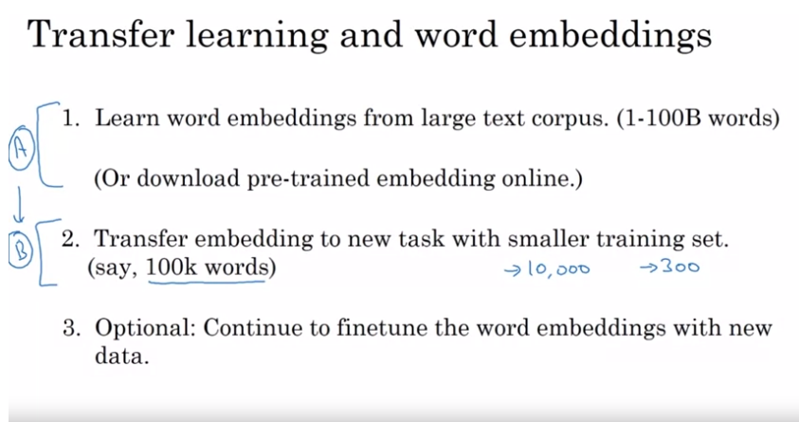

**APPLICATION: ANALOGIES:**

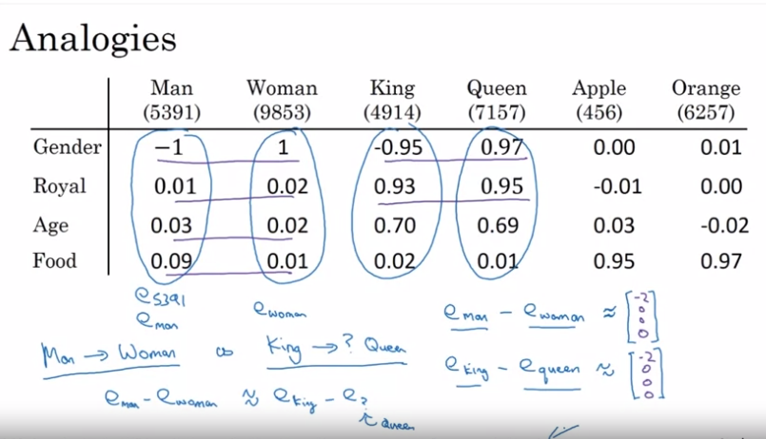

Here as ek-eq=em-ew so ew=em-ek+eq so we measure the max similarity between lhs and rhs here using cosine similarity which is normalized dot product

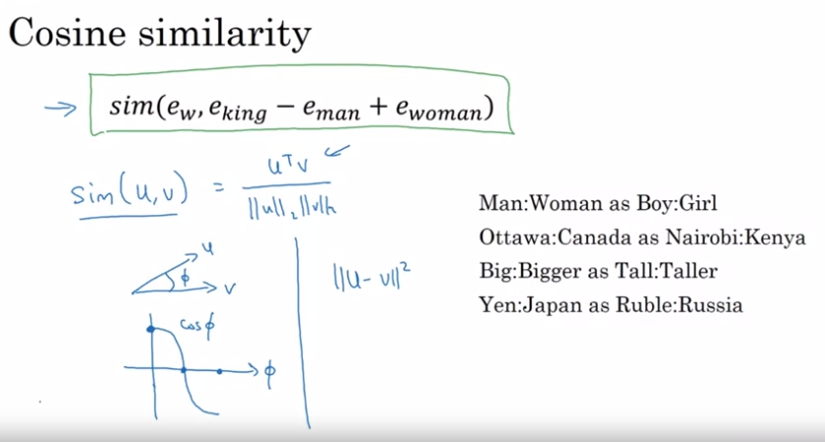

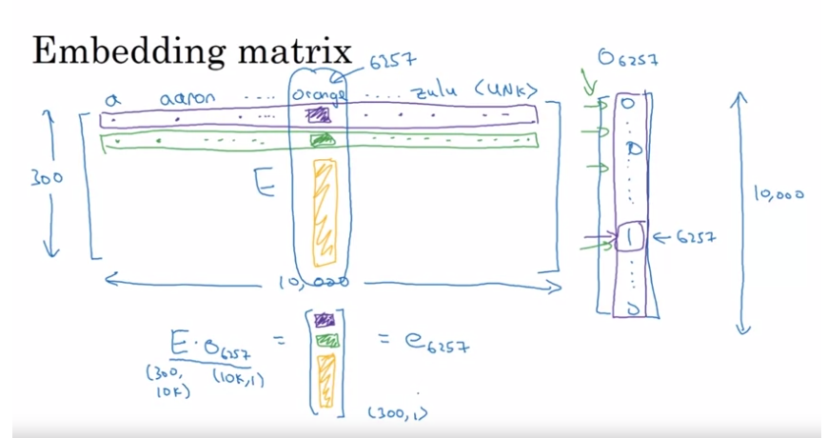

**ALGORITHMS TO TRAIN WORD EMBEDDINGS**

Each word has a one hot encoding and is dotted with the feature vector of size 300 to get feature vectors for each word and they are passed to NN layer and then softmax to predict next word

Here NN and softmax have W,b also feature vectors of last 4(hyperparameter) layers are stacked as one long vector as input(300*4=1200 dimensional)

Gradient descent is used to learn the parameters here

For lang models last few words are used as context but for learning word embeddings itherthings can be used as context

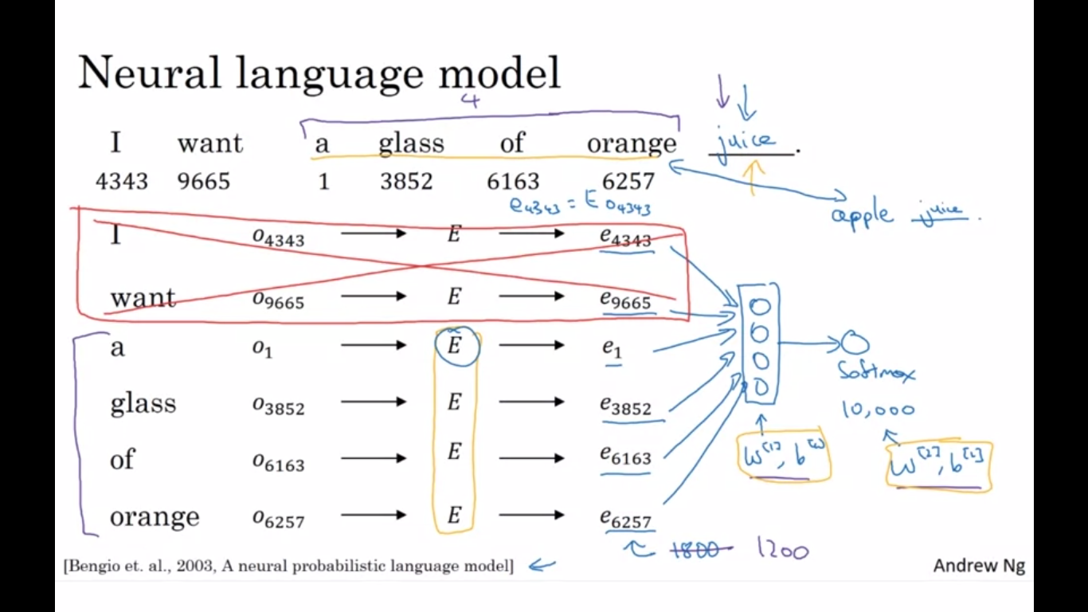

We can use **skip-gram Word2vec** model which co relates any pair of words in + - 10 words instead of using last 4 words

C -> context word, t-> target word so Oc.E=ec

ec is passed to softmax to predict yhat.softmax gives the probability of t given c ie p(t\c)

For calculating softmax we average the prob hence its computationally expensive

So we can use **hierarchical softmax classifier** where the word is found out like binary sort

Time is log(n) instead of n (common words are on top)

**Continuous backward model:** surrounding words are used to sample middle word

**Negative sampling:** we choose one correct set of context c and target t and label them as 1(true) and then for the same c choose k random t from the dictionary and label them as 0(negative sampling) assuming no analogy betw them and then train a binary classifier using sigmoid

So instead of finding prob for 10000 words we do binary classification for only k+1 words

K for large models is 2-5 and for small is 5-20

**Glove algorithm(global vectors for word representation)**

Xij is the count of how often i and j words appear in proximity of each other

It minimizes the difference between thetai.ej and log(Xij)

We use f(Xij) to account for problem of log0 and also for giving proper weight to different words

Thetai and ej almost play the same role here

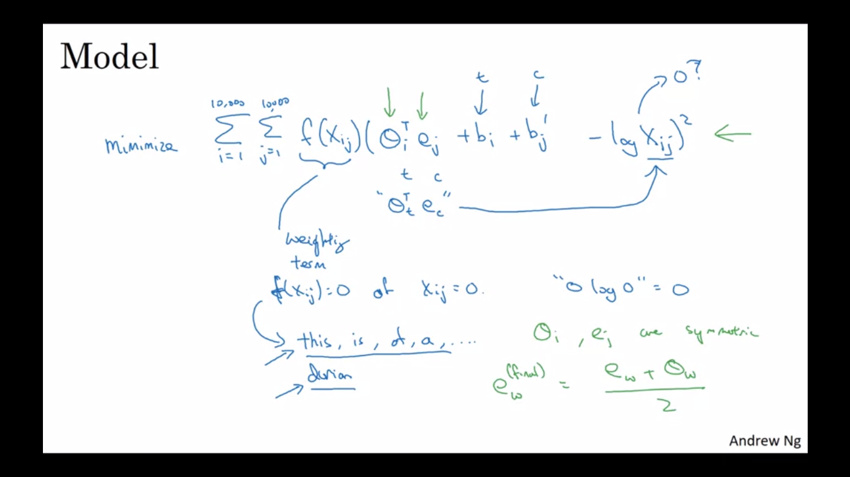

**SENTIMENTAL ANALYSIS:**

Word embeddings can be used to train such models even when labelled dataset is very small

The word embeddings are trained on 100B words and then used in this analysis with 10k-100k dataset

The feature vector of overall sentence is calculated from the average of feature vectors of all words and then passed to softmax for prediction

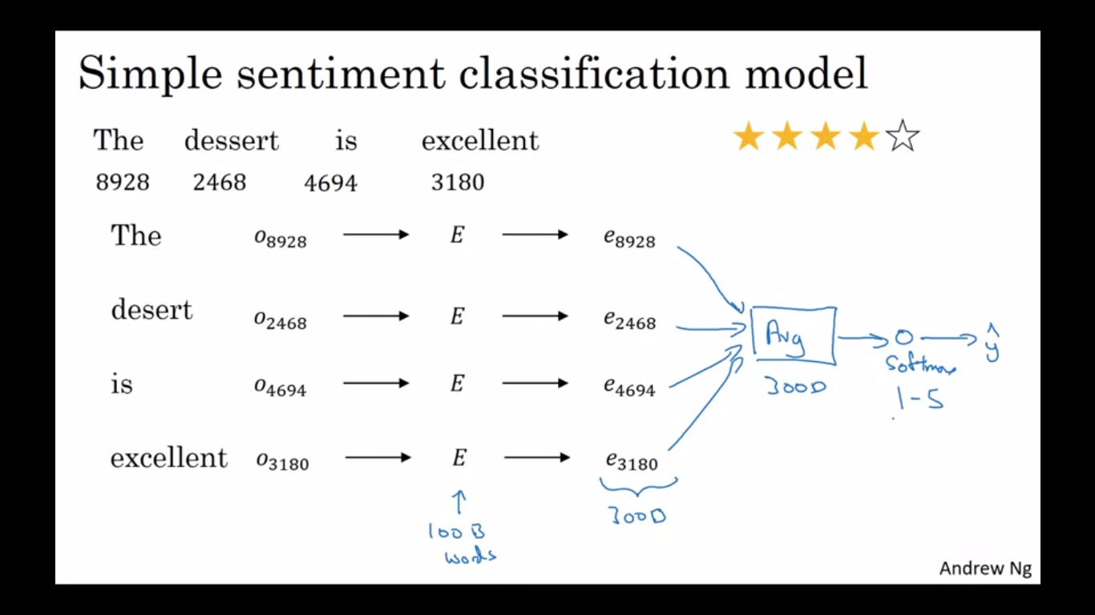

But for the following review the model fails as good appears more and word order is not considered

"Completely lacking in good taste, good service, and good ambiance". But the word good appears a lot.

Hence a RNN is used for sentiment analysis where each feature vector is to rnn cells and finally softmax is applied

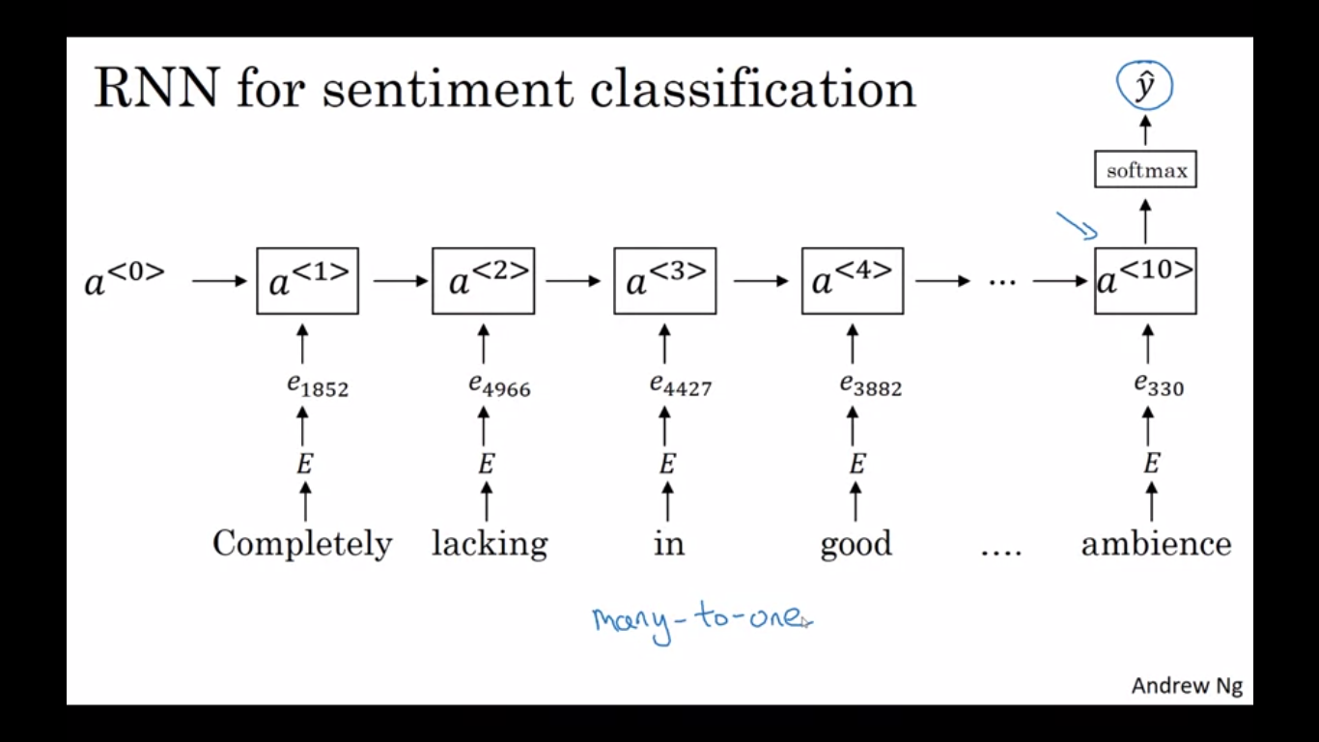

**REDUCING BIAS IN WORD EMBEDDINGS:**

Machine learning algorithms are being used to make very important decisions. They're influencing everything ranging from college admissions, to the way people find jobs, to loan applications, whether your application for a loan gets approved, to the criminal justice system, even sentencing guidelines. Learning algorithms are making very important decisions and so I think it's important that we try to change learning algorithms to diminish as much as is possible, or, ideally, eliminate these biases

Word embeddings gets biased by gender/ethics/class and others from the text they are trained on

One of the techniques used to eliminate bias is

Take the avg of diff of words like man,women boy,girl he,she and find the direction of bias and for words like doctor get it to the line of non bias dir using avg

Then adjust the words like man and women using LA to be equidistant from non bias words

Do linear classification to find words which should be unbiased and for adjusting usually hand picking can work

This is area of current research and other methods can be employed

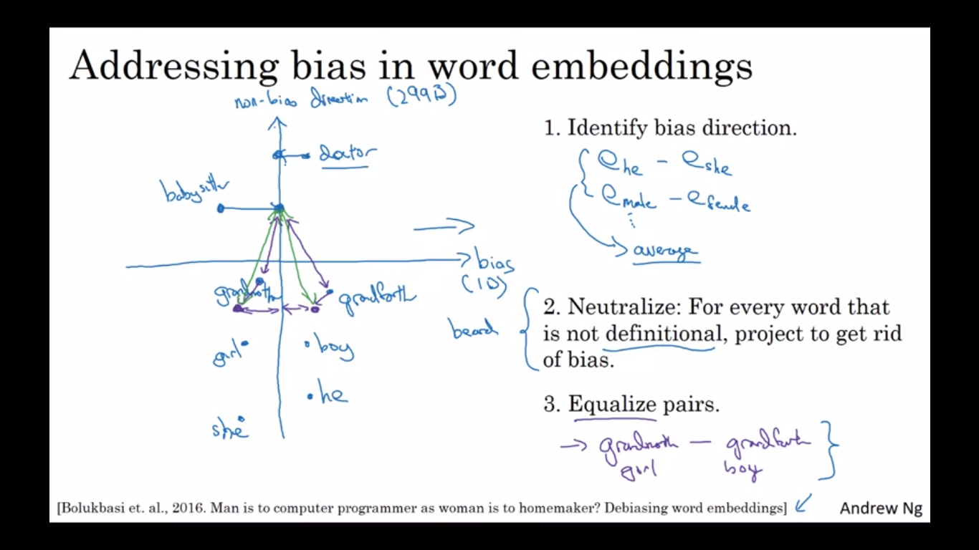

**WEEK 3:**

Below is an example of encoder decoder network, encoding french sent and ddecoding as an english sent

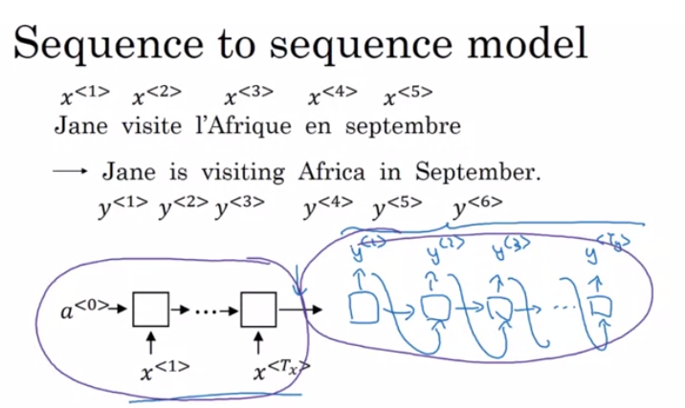

**Image captioning** encoder is CNN generating feature vector from image and decoder is RNN generating sequence for caption

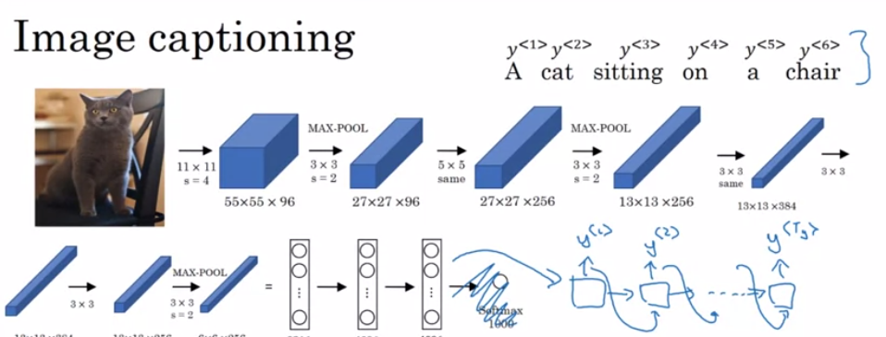

Machine translation is a conditional language model

For language model, output is given as next input but in machine translation, the sent is encoded and then the output is generated by passing each output again to network

Greedy search is not used which maximizes prob of each word in output given previous sequence

Rather prob of whole sent is maximized as a whole

(watch videos from beam search to blue score)

**ATTENTION**

alpha(t, t_prime) is the amount of attention you should paid to a(t_prime ) when you're trying to generate the t th words in the output translation

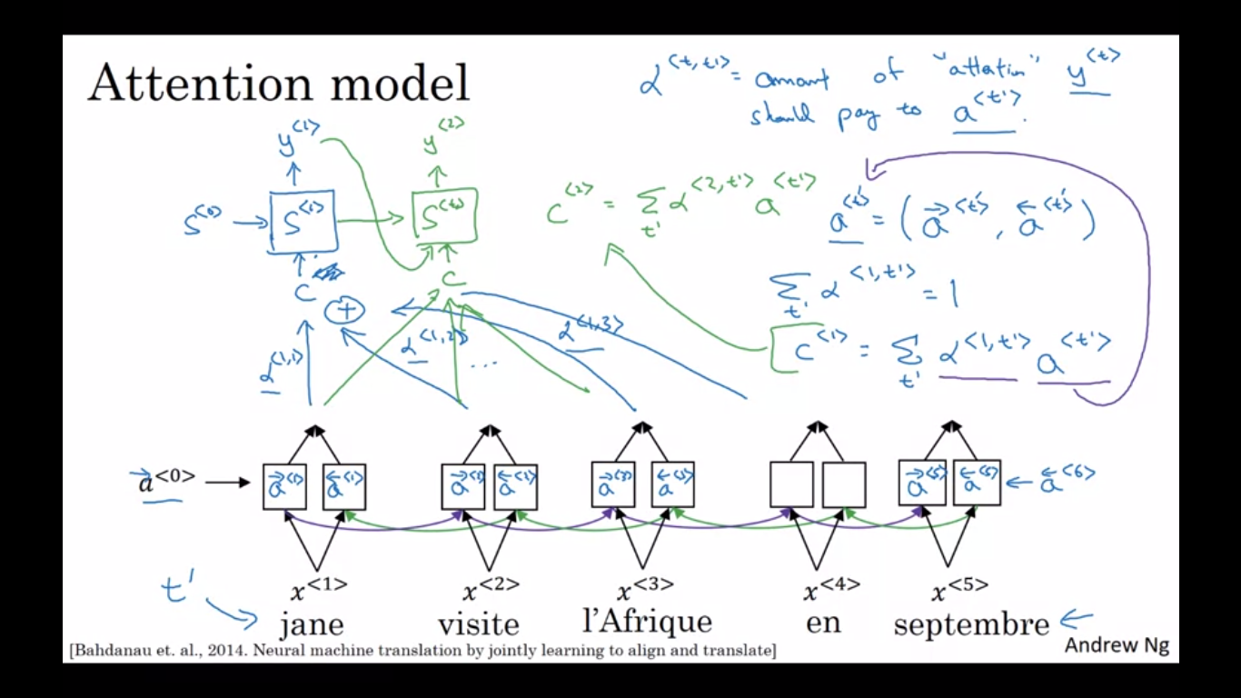

Alpha is softmax probability of any point in input sequence calculated using e(t’,t) which is got by training small one hidden layer NN

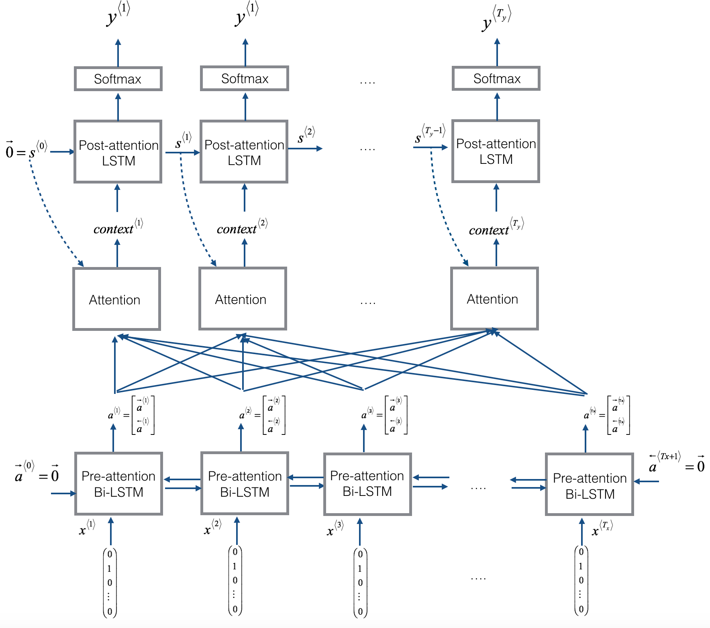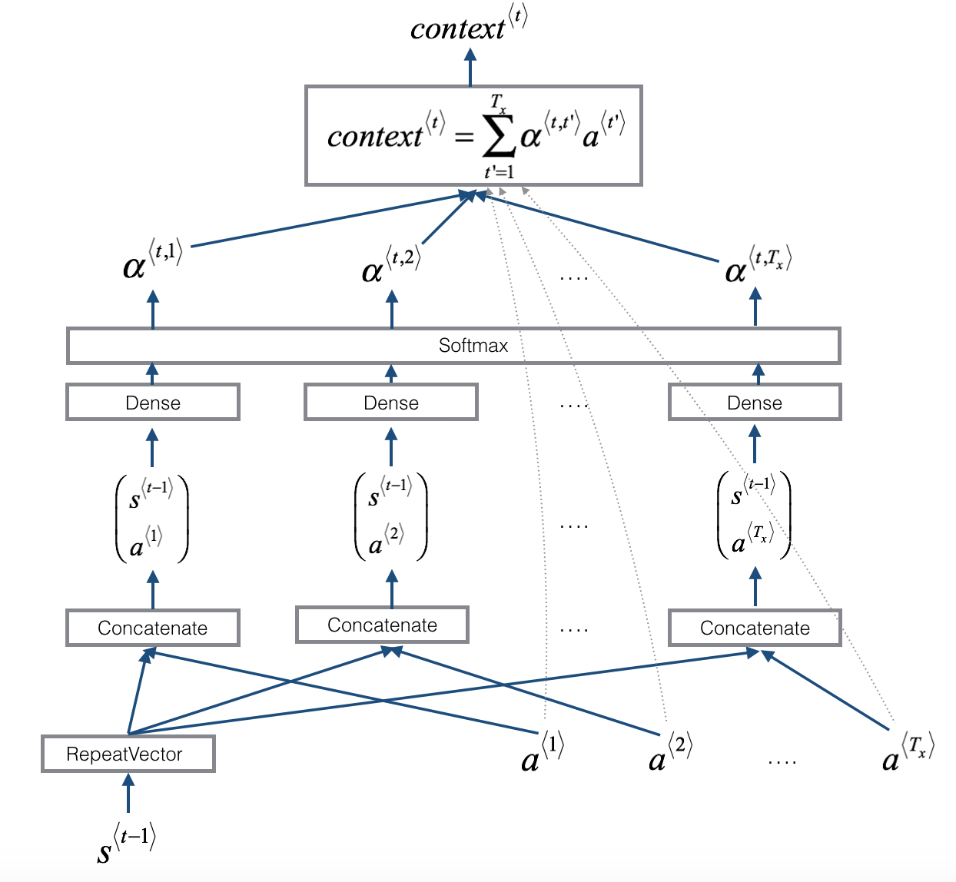

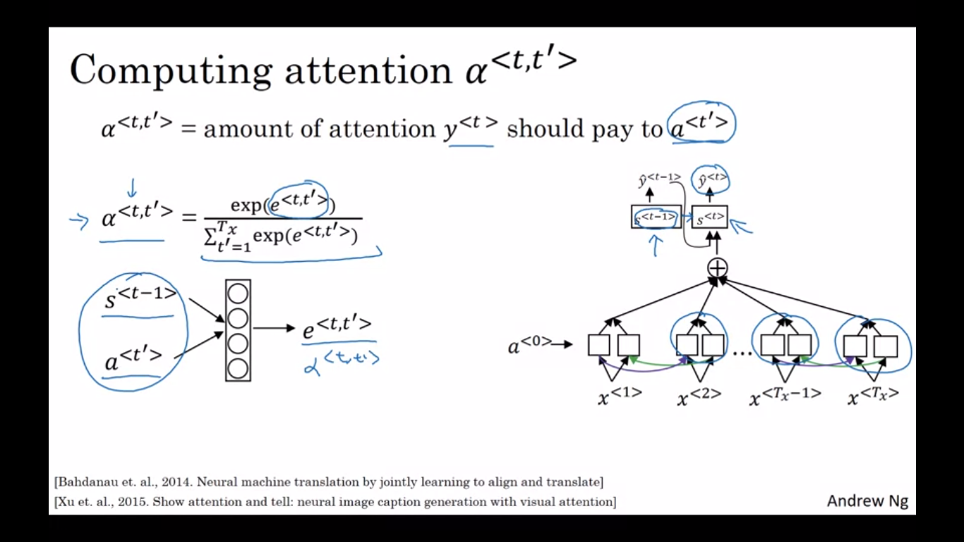

Algo takes quadratic time to run as T_x*T_y

